**DAV HZL SR. SEC. SCHOOL, DARIBA**

**TENTATIVE CO-CURRICULAR ACTIVITIES 2024-25**

|  |  |  |
| --- | --- | --- |
| **Date** | **Class** | **Activity (Events)** |
| 06/04/2024 | III TO V | Cinematic Odyssey: Arya Samaj Chronicles |
| VI TO VIII | Narrative Alchemy: Crafting English Tales |
| IX TO XII | Lens Enchantment: Interclass Cinematic Journey |
| 20/04/2024 | III TO V | Soliloquy Symphony: Mastering English Monologues |
| VI TO VIII | Dramatic Flourish: Theatrical Skits in English |
| IX TO XII | Electoral Insights: Interclass PowerPoint Showdown |
| 04/05/2024 | III TO V | Artistry Unleashed: Collage Creation Extravaganza |
| VI TO VIII | Sculpting Stories: From Clay to Chronicle |
| IX TO XI | Pixel Perfection: Design Delights with Photoshop |
| 05/07/2024 | III TO VIII | Green Horizon: Plantation Expedition |
| 06/07/2024 | III TO V | Calligraphy |
| VI TO X | Echoes of Ecology: English Environmental Orations |
| 11/07/2024 | III TO XII | Leadership Unveiled: Investiture Spectacular |
| 20/07/2024 | III TO V | Lexical Showdown: Spellbinding Spell Bee |
| VI TO VII | Verbal Voyage: Vocabulary Ventures |
| IX TO XI | Enlightening Discourse: TED Talk Showdown |
| 03/08/2024 | III TO V | Culinary Chronicles: Fireside Cooking & Artistry |
| VI TO IX | Taste Temptations: Culinary Competition |
| 17/08/2024 | III TO VIII | Cultural Kaleidoscope: Rangoli, Rakhi& Arya Samaj Quizzes |
| 31/08/2024 | III TO V | Social Science Showdown: Quiz Quest |
| VII TO X | Parliamentary Prowess: Youth Debate Showdown |
| 06/09/2024 | III TO V | Hindi Heritage: Crafting Original Stories & Poems |
| VI TO VII | Hindi Heritage: Crafting Original Poems |
| VIII TO X | Declamatory Divinity: Hindi Oratory Odyssey |
| 05/10/2024 | III TO V | Blogosphere Brilliance: Crafting Digital Chronicles |
| VI TO VII | Wall Wonders: Mural Masterpieces |
| VIII | Wonders on earthen plates |
| 19/10/2024 | III TO V | Moral Mosaic: Hindi Skits on Values |
| VI TO IX | Theatrical Tribute: Great Personality Dramatizations |
| 08/11/2024 | III TO V | Melodic Medley: Songster Showdown |
| VI TO IX | Devotional Delights: Bhajan Bliss |
| 23/11/2024` | III TO V | Innovation Illuminated: Inventors' Showcase |
| VI TO VII | Journey of a Dreamer;Biography |
| VIII TO IX Sci. | Scientific Sorcery: Enchanting Science Magic |
| 07/12/2024 | III TO V | Literary Legacy: Bookmark Bonanza |
| VI TO VIII | Informative Imprints: Brochure Brilliance |
| 21/12/2024 | III TO IX | Math Marvels: Exploring Fun & Practical Mathematics |
| 18/01/2025 | III TO VII | Patriotic Penmanship: Slogan Sketching & Doodling |
| 31/01/2025 | III TO V | Resourceful Innovation: Waste Material Wonders & Presentations |

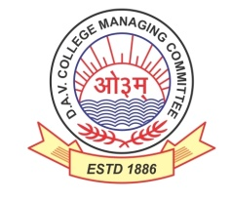

DAV HZL Sr. Sec. School dariba

rajsamand (raj.)

DAV HZL Sr. Sec. School dariba, rajsamand(raj.)

Split-up Syllabus

Class- III

Split-up Syllabus & Activities

for the session

2024-25

Class-VIII

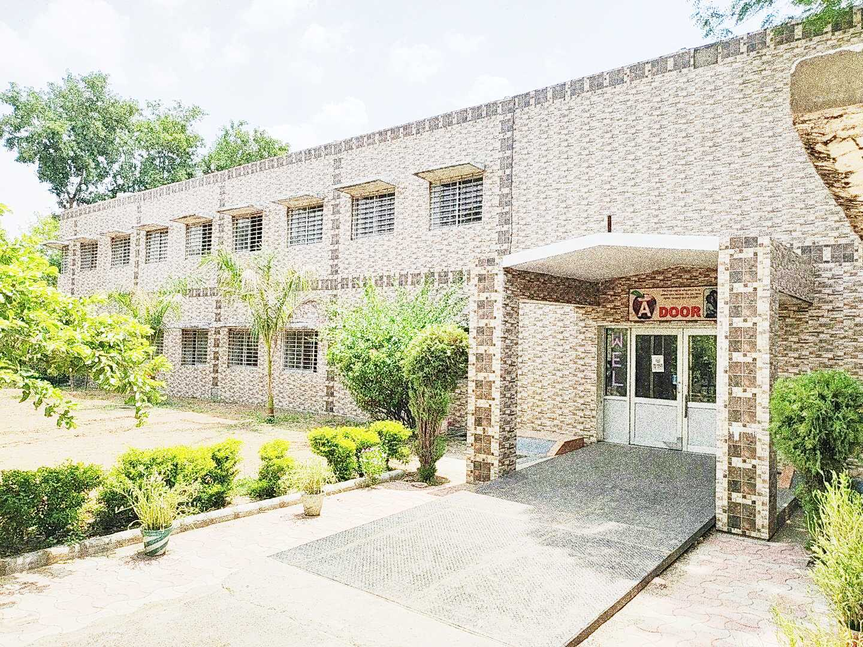

Address : Rajpura-Dariba, Distt. – Rajsamand (Raj.) 313211

Contact : (02952)265130 Email : davhzl_dariba@yahoo.com

|  |  |  |
| --- | --- | --- |
| **Subject** | **PT- I** | **PT- II** |
| English | Eng. Lit. – Lesson – 1 , 2  Practice Book – Lesson – 1 | Eng. Lit. – Lesson – 4 & 5  Practice Book – Lesson – 2 |
| Hindi | Kku lkxj % ikB & 1, 2  vH;kl lkxj % ikB & 1, 2 | Kku lkxj % ikB & 3, 4  vH;kl lkxj % ikB & 3, 4 |
| Maths | Chapter – 1, 2 | Chapter – 3, 4 |
| Science | Lesson – 1 , 2 | Lesson – 3, 4 |
| S.St. | Lesson – 1 & 8 | Lesson – 3, 5, 13 |
| laLÑr | ikB & 1] 2 milxZ&vO;; | ikB & 3] 4] loZuke nh?kZ o xq.k lfU/k] |
| Computer Sc. | Chapter – 1 | Chapter – 2 |
| Moral Edu. | ikB & 1 , 2 | ikB & 3 , 4 |
| G. K. | Unit- 1 | Unit – 2 |

|  |  |
| --- | --- |
| **Subject** | **Mid Term** |
| English | Eng. Lit. – Lesson – 1 to 6 , Practice Book – Lesson – 1 to 5  Reader Book – Unit 1 to 3 |
| Hindi | Kku lkxj % ikB & 1] 2] 3] 4] 5] 6] 7] 8] 9] 10  vH;kl lkxj % ikB & 1] 2] 3] 4] 5] 6] 7] 8] 9] 10  vifBr x|ka'k |
| Maths | Ch. – 1, 2, 3, 4, 5, 10, 11, 12 |
| Science | Lesson – 1 to 10 |
| S. St. | Lesson – 1, 2, 3, 5, 8, 10, 11,13, 16, 17 & 18 |
| laLÑr | ikB & 1 ls 6] rFkk O;kdj.ke~ milxZ] vO;;] izR;;%] lfU/k] 'kCn:i] /kkrq:i] la[;k 1 & 50] miin foHkfDr] ¼izFkek ls prqFkhZ½] vifBr x|ka'k] fp=o.kZue~] vuqPNsn ys[kue~]  laokne ] i= ys[kue कथा ys[kue~] वंर्ण विच्छेद |
| Computer Sc. | Chapter – 1 to 4 |
| Moral Edu. | ikB & 1 ls 9 |
| G. K. | Unit – 1,2 & 3 |
| Drawing | Page No. 2 to 20 |
| **Subject** | **PT- III** |
| English | Eng. Lit. – Lesson –7, 8 Practice Book – Lesson – 6 |
| Hindi | Kku lkxj % ikB & 11, 12 vH;kl lkxj % ikB & 11, 12 |
| Maths | Chapter – 7,16 |
| Science | Lesson – 11, 19, 20 |
| S.St. | Chapter – 21, 14 & 19 |
| laLÑr | ikB & 7] 8 laokne ] i= ys[kue |
| Computer Sc. | Chapter – 5 & 6 |
| Moral Edu. | ikB & 10, 11 |
| G. K. | Unit – 4 |

|  |  |
| --- | --- |
| **Subject** | **Final Term** |
| English | Complete Syllabus |
| Hindi | Mh- ,- oh- cksMZ ds vuqlkj |
| Maths | As Per DAV Board |
| Science | As Per DAV Board |
| S.St. | As Per DAV Board |
| laLÑr | Mh- ,- oh- cksMZ ds vuqlkj |
| Computer Sc. | Chapter – 5 to 9 |
| Moral Edu. | Mh- ,- oh- cksMZ ds vuqlkj |
| G. K. | Unit – 4 to 6 |
| Drawing | Page No. – 21 to 40 |

|  |  |
| --- | --- |
| **Exam** | **TENTATIVE DATES OF EXAM** |
| **PT – I** | First Week of May 2024 |
| **PT- II** | First Week of August 2024 |
| **MID – TERM** | Third Week of September 2024 |
| **PT – III** | Last week of November 2024 |
| **Pre-Board** | January 2025 |
| **FINAL TERM** | As per DAV Board |